KENDRIYA VIDYALAYA RWF YELAHANKA BANGALORE-64
CBSE RESULT 2019-20
CLASS X
NO. APPEARED: 134 NO.PASSED : 134 PASS PERCENTAGE: 100 PI: 62.16
TOPPERS:
Position | Name of the student |  | Marks Obtained | Marks in %
1 | ATHULYA RAJ | 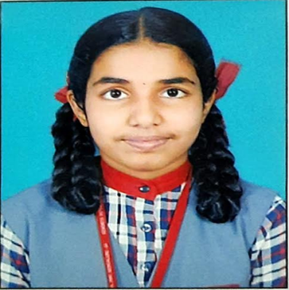 | 485 | 97.00
2 | NITIN VERMA | 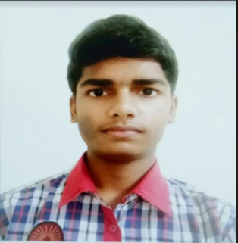 | 481 | 96.20
3 | SARANG R | 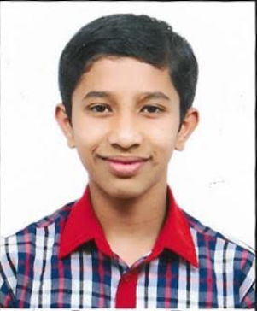 | 468 | 93.60

SUBJECT TOPPERS:
Subject | Marks | Name of the student | Class & Sec.
HINDI COURSE-A | 99 | ATHULYA RAJ | X B
ENGH LNG & LIT. | 96 | ATHULYA RAJ | X B
MATHS STANDARD | 98 | ATHULYA RAJ | X B
MATHS STANDARD | 98 | NITIN VERMA | X A
MATHS BASIC | 75 | S NEHASHREE | X A
COMM. SANSKRIT | 97 | H M BRUNDA | X A
SCIENCE | 98 | NITIN VERMA | X A
SOCIAL SCIENCE | 97 | NITIN VERMA | X A
INFO TECHLGY(O) | 100 | ATHULYA RAJ | X B
INFO TECHLGY(O) | 100 | BHUVAN K H | X A
INFO TECHLGY(O) | 100 | GAGANA K | X C
INFO TECHLGY(O) | 100 | K S SUYOG | X B
INFO TECHLGY(O) | 100 | SHREYAS Y S | X C
INFO TECHLGY(O) | 100 | UCHIT N M | X A

KENDRIYA VIDYALAYA RWF YELAHANKA BANGALORE-64
CBSE RESULT 2019-20
CLASS XII
NO. APPEARED : 72 NO. PASSED : 71 PASS PERCENTAGE: 98.6 PI: 73.65
TOPPERS:
Position | Name of the student |  | Marks Obtained | Marks in %
1 | ANJANA MADHAVAN | 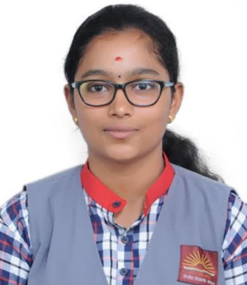 | 476 | 95.20
1 | KUPPA SHASHANK | 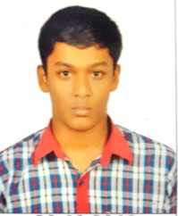 | 476 | 95.20
2 | SUPREETH S | 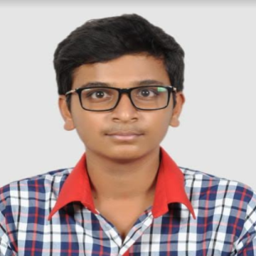 | 471 | 94.20
3 | SUBHENDU DASH | 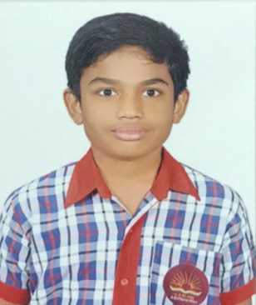 | 468 | 93.60
3 | ADITI JOSHI | 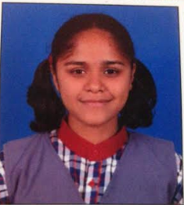 | 468 | 93.60

SUBJECT TOPPERS:
Subject | Marks | Name of the student | Class & Sec
ENGLISH CORE | 97 | HIMANSHU PRABHU | XII A
ENGLISH CORE | 97 | NATASHA RACHEL SINU | XII A
HINDI CORE | 86 | AANYA PHADKE | XII A
MATHEMATICS | 95 | ADITI JOSHI | XII B
MATHEMATICS | 95 | ANJANA MADHAVAN | XII A
MATHEMATICS | 95 | KUPPA SHASHANK | XII B
MATHEMATICS | 95 | NATASHA RACHEL SINU | XII A
MATHEMATICS | 95 | SAATVIK SINHA | XII B
MATHEMATICS | 95 | SUPREETH S | XII A
PHYSICS | 95 | ADITI JOSHI | XII B
PHYSICS | 95 | ANAGHA S DIXITH | XII A
PHYSICS | 95 | ANAND KUMAR | XII B
PHYSICS | 95 | ANJANA MADHAVAN | XII A
PHYSICS | 95 | BHAGYA M | XII A
PHYSICS | 95 | DHANUSHA N | XII A
PHYSICS | 95 | G PAVITHRAN | XII A
PHYSICS | 95 | HARSHINI | XII A
PHYSICS | 95 | HARSHITHA R | XII B
PHYSICS | 95 | HIMANSHU PRABHU | XII A
PHYSICS | 95 | K S PRIYANKA | XII A
PHYSICS | 95 | KUPPA SHASHANK | XII B
PHYSICS | 95 | KUSHWANTH SOMAIAH | XII A
PHYSICS | 95 | L STEPHEN PRANEETH | XII A
PHYSICS | 95 | NATASHA RACHEL SINU | XII A
PHYSICS | 95 | R BLESSY HEPSIBA | XII A
PHYSICS | 95 | R BRINDA | XII A
PHYSICS | 95 | SAATVIK SINHA | XII B
PHYSICS | 95 | SHUBHAPRADHA M | XII A
PHYSICS | 95 | SIDDHARTHA HADIMANI | XII B
PHYSICS | 95 | SUBHENDU DASH | XII B
PHYSICS | 95 | SUPREETH S | XII A
PHYSICS | 95 | THARUNYA S | XII B
PHYSICS | 95 | THOMAS JACOB THAZHATHILLATH | XII B
PHYSICS | 95 | VIVEK KUMAR | XII A
CHEMISTRY | 95 | ANJANA MADHAVAN | XII A
CHEMISTRY | 95 | B KAVYA | XII B
CHEMISTRY | 95 | HARSHINI | XII A
CHEMISTRY | 95 | KUPPA SHASHANK | XII B
CHEMISTRY | 95 | SAATVIK SINHA | XII B
CHEMISTRY | 95 | SUBHENDU DASH | XII B
CHEMISTRY | 95 | THOMAS JACOB THAZHATHILLATH | XII B
COMPUTR SCIENCE | 96 | ADITI JOSHI | XII B
COMPUTR SCIENCE | 96 | KUPPA SHASHANK | XII B
BIOLOGY | 99 | R BLESSY HEPSIBA | XII A

