KENDRIYA VIDYALAYA RWF YELAHANKA BANGALORE-64
CBSE RESULT 2022-23 CLASS X
NO. APPEARED: 126 NO. PASSED: 126 PASS PERCENTAGE: 100 P I: 60.99
TOPPERS:
Position | Name of the student |  | Marks Obtained | Marks in %
1 | S AAYUR GANESH | 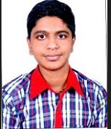 | 494 | 98.80
2 | H SWATHI PADMAL | 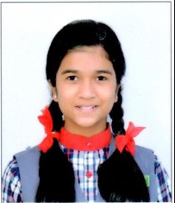 | 477 | 95.40
3 | DRITI HANSIKA M N | 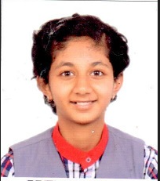 | 459 | 91.80

SUBJECT TOPPERS:
Subject | Marks | Name of the student | Class & Sec.
ENGLISH LANG & LIT. [184] | 99 | S AAYURGANESH | X A
ENGLISH LANG & LIT. [184] | 99 | H SWATHI PADMAL | X B
HINDI COURSE-A [002] | 95 | CHANDUSHREE K | X B
SANSKRIT [122] | 100 | S AAYURGANESH | X A
MATHEMATICS STANDARD [041] | 99 | S AAYURGANESH | X A
MATHEMATICS STANDARD [041] | 99 | H SWATHI PADMAL | X B
MATHEMATICS BASIC [241] | 75 | TWESHA MADHAVAN | X A
SCIENCE [086] | 99 | S AAYURGANESH | X A
SOCIAL SCIENCE [087] | 98 | CHANDUSHREE K | X B
SOCIAL SCIENCE [087] | 98 | ANUKRITI JEPH | X C
SOCIAL SCIENCE [087] | 98 | G S SANJANA | X C
ARTIFICIAL INTELLIGENCE [417] | 100 | DRITI HANSIKA MN | X A
ARTIFICIAL INTELLIGENCE [417] | 100 | GLENORA PREEMAL CRASTA | X B
ARTIFICIAL INTELLIGENCE [417] | 100 | MUSKAN KUMARI | X B

KENDRIYA VIDYALAYA RWF YELAHANKA BANGALORE-64
CBSE RESULT 2022-23 CLASS XII
NO. APPEARED: 77 NO. PASSED: 76 PASS PERCENTAGE: 98.7 P I: 62.27
TOPPERS:
Position | Name of the student |  | Marks Obtained | Marks in %
1 | MEENA D S | 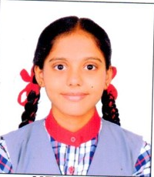 | 481 | 96.20
2 | VISHAL KUMAR GOWDA | 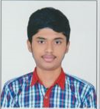 | 478 | 95.60
3 | NEHA BALAMURUGAN | 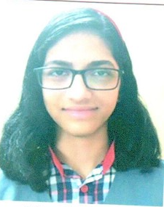 | 473 | 94.60
SUBJECT TOPPERS:
Subject | Marks | Name of the student | Class & Sec
ENGLISH CORE [301] | 99 | DEVANGANA S | XII A
ENGLISH CORE [301] | 99 | SHREYA | XII A
HINDI CORE [302] | 87 | A R MEGHANA | XII A
MATHEMATICS [041] | 95 | MEENA D S | XII A
MATHEMATICS [041] | 95 | NEHA BALAMURUGAN | XII A
MATHEMATICS [041] | 95 | VISHAL KUMAR GOWDA | XII B
PHYSICS [042] | 97 | VISHAL KUMAR GOWDA | XII B
CHEMISTRY [043] | 99 | MEENA D S | XII A
BIOLOGY [044] | 95 | DEVASHISH SHARMA | XII A
BIOLOGY [044] | 95 | E MADHIMALAR | XII A
BIOLOGY [044] | 95 | HARSHAL ANAND | XII A
BIOLOGY [044] | 95 | MEENA D S | XII A
BIOLOGY [044] | 95 | NEHA BALAMURUGAN | XII A
BIOLOGY [044] | 95 | A R MEGHANA | XII A
COMPUTR SCIENCE [083] | 98 | SIRI D A | XII B

